,

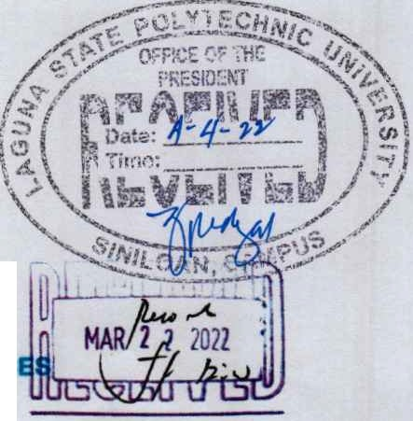

Republic of the Phlllpplnes

C)

Llguna &tate tlolptecbnic mniber!titp

Province of Laguna

OFFICE OF THE STUDENT AFFAIRS ANO SERVIC

March 22, 2022

MARIO R. BRIONES, Ed.D

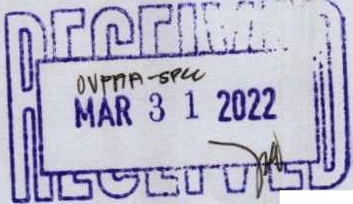

*University* President

*Vice Chairperson, Board of Regents* (SOR)

## lSPUSystem

Dear Sir:

*Greetings from the Officeof the* Student *Affairs and Services!* -- · - ·--- - - -·

In reference to the output of the Meeting conducted by the Office of *the* Student Affairs and Services last March 18, 2022 at LSPU San Pablo, it is agreed that the formulation of Implementing Rules and Regulations of the Newly Approved Mental Health Polky shall be composed of a Technical Working Group. The function of this TWG is to formulate guidelines of Implementation and ensurethe proper discharge of the services to both students and employees of this university.The TWG shall composed of *the* following:

Chairman Co<halr Members

Consultants

OSAS Director

Health & Guidance Unit {Focal Person)

OSAS Chairpersons, GAO Chairpersons, HR Director, Federated Faculty Association President & Federated SSC President

Senior Officials & GAO Director

Further, the above-named personnelwill also take part of the same positionIn the TWG for crafting the Guidelines for Services to the Student with Special Needs.We, at the Office of the Student Affairs and Services believes that the output of this TWG will strongly connect to the students and other stakeholders even in time of pandemk. Rest assured that the following persons will work hand-In-hand to meet the demand of this office.

Iam hopingfor your favorable response regarding this matter.Thank you and keep safe always. Yours in t jof student affairsand services,

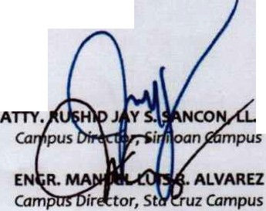

JAYSON ;;J:{;..YTA, MRD

*Director,OSAS*

Noted:

# M.

RecommendingApproval:

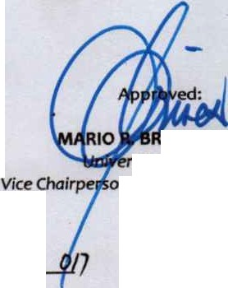

cl.hu o

*Vice President for* Academic *Affairs*

IONES, Ed.D.

sity President

*n, Board of Regents* (SOR)

# A :.:- ..

## ..n---i.

I· • -.,.-,.-...

LSPU:OSAS-Rl- Rev.O

10 August 2016